# Setting up the scenarios

A mass balance model of CA groundwater

Groundwater

Stock

Flow in geom_text(x = 2030, y = 25,

label = "flow out",

color = "red")

Flow out geom_text(x = 2030, y = 25,

label = "flow out",

color = "red")

The flow and stock California groundwater can be analyzed with a simplified mass balance model as shown above. In 2000, the expected value of groundwater stock was 350x109 m3 with a standard deviation of 115x109 m3. Assuming normal distribution, there is a 90% chance that the initial groundwater stock is between 190x109 m3 and 550x109 m3 in 2000.  Then, I determined the flow based on “Visualizing a Stochastic Model of Californian Water Resources Using Sankey Diagrams” by Curmi et al. In 2000, the annual input to the groundwater is 12.8x109 m3 while the annual loss is 18.2x109 m3. In 2050, the annual input is projected to decrease to 10.3x109 m3 while annual loss will increase to 27x109 m3.

# Amount of groundwater depletion 2000-2050

From 2000 to 2050, the magnitude of groundwater extraction exceeds recharge every year. I plotted the flow in and flow out during these years assuming a linear relationship (Figure 1). The light-gray-shaded area represents the amount of cumulative groundwater depletion, the difference between flow out and flow in from 2000 to 2050, which is calculated below:

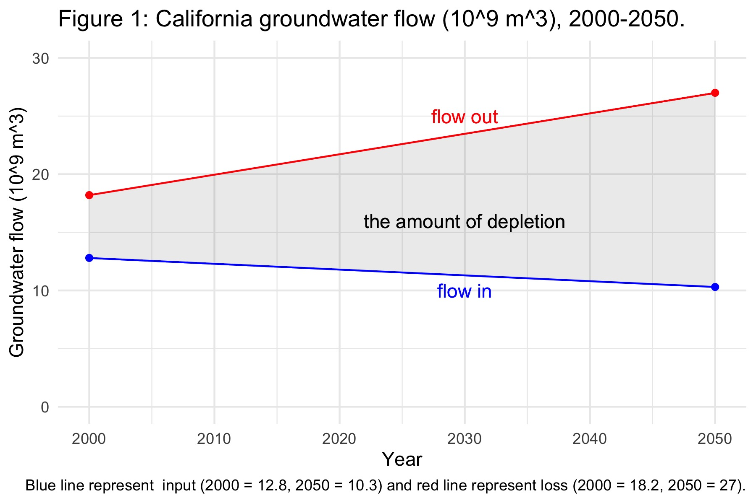

Therefore, the total amount of groundwater depletion is estimated to be 552.5x109 m3. The fitted line for flow in is , and that for flow out is .

Groundwater stock in 2050

I found the groundwater stock in 2050 by subtracting the depletion amount out of the initial amount in 2000 under three initial scenarios: expected volume, lower estimate volume, and upper estimate volume.

*Expected volume*

With an expected initial groundwater stock of 350x109 m3, the volume in 2050 is estimated to be -192.5x109 m3. The negative value indicates groundwater in California will completely run out before 2050.